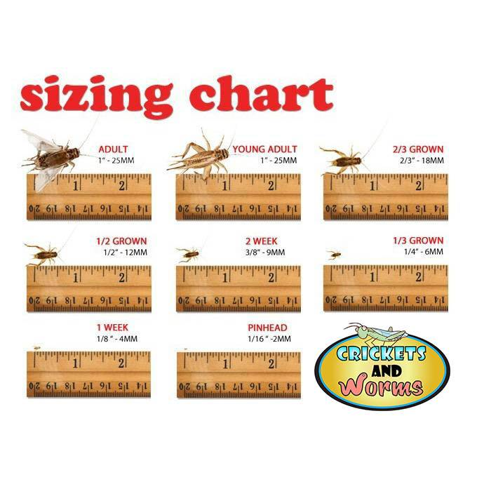
Click Here for Unpacking Video

www.CricketsandWorms.com

Cricket Care Sheet

Common Group – Gryllinae

Common Name – Common Brown Cricket (Acheta domestica) or Black Field Cricket (Gryllus bimaculatus)

Scientific Name – Acheta domestica, Gryllus bimaculatus
Distribution Area Generally believed to have introduced into Europe and North America from arid and semi-arid areas of northern Africa or southwest Asia.
Natural History Live Crickets are hearty insects and do not really require any special handling, just remember that they are living creatures and need normal, common sense care.
Size and Longevity Common brown crickets can grow up to 1 ¼ inch in size and live 8 to 12 weeks from larva to adulthood. The black field cricket can grow up to 2 inches and live 8 to 12 weeks from larva to adulthood.
Housing You have many options when it comes to housing crickets. You can keep them in a 10-gallon glass tanks, rubber storage tubs with ventilation holes, or a 5-gallon bucket with a lid and vent holes will work as well. If using a tub or bucket, be sure to cover your ventilation holes with a fine metal mesh to prevent escapes or pest insects from entering. Be creative, and pick something that works best for you. Always be sure to provide adequate ground space to allow room food and water dishes, while still allowing of plenty of standing room for the crickets.
Heating and Lighting With crickets, no special lighting is needed. Any ambient room lighting will be sufficient. Maintain moderate temperatures between 70 to 85 degrees F for crickets of all sizes. You can keep smaller crickets, ½ inch or smaller, at temperatures between 80 to 90 degrees F to encourage quicker growth, but this is not necessary.
Substrate and Furnishing There are a couple of options out there for bedding. You can put no bedding down at all, but you will have to maintain the bottom cleanliness much more frequently by scooping out any dead crickets and their feces. Other options include pine shavings, SANI CHIPS, SHERREDED ASPEN, or ORCHID BARK. If orchid bark is used, let it dry out first as it tends to be fairly moist in the bag.
Crickets need lots of climbing areas and places to get away from each other. Otherwise they will actually smother and suffocate one another. The best way to keep this from happening is by stacking egg crate in the cage either vertically or horizontally.
Here’s another good tip to keep in mind; it is hard to collect crickets off of big pieces of egg crate to feed to your animals. Try providing a few used paper towel tubes and/or toilet paper rolls in which the crickets will hide. These are much easier to shake crickets out of and into any container you wish to use. When feeding crickets to your herps, a handy feeding device can be constructed quickly and cheaply from items found around the home. Take an old, clean milk jug, and using a razor knife cut off and discard the bottom (be sure to keep the screw on top). Stuff the hollow handle with a napkin or paper towel so the crickets can’t hide in there. Then shake the crickets right into the wide mouth opening (where the bottom was). The container should be tall enough to keep your crickets from escaping, as is tall and has smooth sides. Add your preferred calcium and mineral supplements and shake gently. Unscrew the top over your cage and the crickets will funnel right into the cage. No mess and no loose crickets!
Water and Humidity Crickets typically do poorly with high levels of humidity. You can keep them in a relatively dry environment, as they obtain most of their needed moisture through their food. You may also use sliced pieces of Carrots or potatoes for moisture. Keep in mind they must be changed daily as they do dry up and will also attract gnats or fruit flies.
Nutrition Crickets have a large digestive track and is the biggest portion of their body. A good way to look at crickets is as a stomach with legs! Whatever you feed them goes directly into your animal. With that in mind, you will want to feed the crickets a food source that is very nutritious. This process is known as “gut loading”. A good way to gut load your feeder insects is with pre made gut loads such as NATURE ZONE TOTAL BITES, or FLUKER’S ORANGE CUBE COMPLETE CRICKET DIET, which are a vitamin supplement, food and water source all in one.
You can also use a two-part system that incorporates a food and water source separately. REP CAL CRICKET FOOD (dry) and NATURE ZONE CRICKET WATER BITES (moist) are two products that work well together. If you have a picky herp that won’t touch its dry pelleted foods, try feeding it to the crickets instead, as they will eat anything. This way the diets are still being used and transferred to your animal with the feeders being none the wiser. Additionally, you don’t waste anything. Don’t use things like fish flakes or dog food and cat food; it wasn’t designed for your reptiles, and they can cause your animal more harm than good in the long run.
Breeding Crickets are difficult to sex as juveniles, but when they reach adulthood it becomes easy to tell the two genders apart. The female cricket will have an ovipositor (egg laying appendage) extending from the rear, which is quite distinctive and is the easiest way to determine the sex of your crickets. The males also have ridges on their wings, while female’s wings are smooth. This is due to the male’s wings being used to create the 'chirp' that is the cricket’s recognizable mating call.
Adult Crickets will breed quickly if provided with the right conditions. A breeding/egg laying container should be placed in the primary housing container to encourage the females to lay their eggs. This can be a plastic tub containing either a simple substrate of damp cotton wool, paper towels or alternatively it can be a more natural substrate. Moist sand, soil, or coconut husk products like ZOO MED’S ECO EARTH will allow the female to easily burrow before depositing eggs.
This breeding container should be replaced regularly or when it becomes apparent that eggs have been laid. Eggs are whitish yellow in color and should be removed to a separate container to be incubated. If the breeding container is kept warm (between 75 and 80 degrees) and the substrate kept moist, the eggs will hatch in about 10 days.

